**ΑΝΑΦΟΡΑ TVONDEMAND**

# **ΕΙΣΑΓΩΓΗ**

Στην παρούσα αναφορά παρουσιάζουμε:

* Όλους τους νέους πίνακες καθώς και τις τροποποιήσεις που κάναμε στους πίνακες που είχαν δοθεί, για την καλύτερη λειτουργία του προγράμματος.
* Τους κώδικες και τα παραδείγματα για τις Stored Procedures.
* Τους κώδικες και τα παραδείγματα για τα Triggers.

# **ΤΕΧΝΟΛΟΓΙΕΣ ΠΟΥ ΧΡΗΣΙΜΟΠΟΙΗΘΗΚΑΝ ΓΙΑ ΤΟ PROJECT**

* WampServer
* MySQL Workbench
* Visual Studio Code
* PHPMyAdmin
* Sublime Text
* Apache NetBeans
* Eclipse

**ΚΕΦΑΛΑΙΟ 1**

Σε αυτό το κεφάλαιο δίνονται το τελικό σχεσιακό διάγραμμα και η περιγραφή με το πως χειριστήκαμε τους ήδη υπάρχοντες πίνακες.

**A)**

Στο παρακάτω σχήμα φαίνεται το σχεσιακό διάγραμμα της συνολικής Βάσης Δεδομένων.

Δίνεται και ως αρχείο PNG στον φάκελο FINISHED μαζί με το ER (επίσης ως αρχείο PNG).

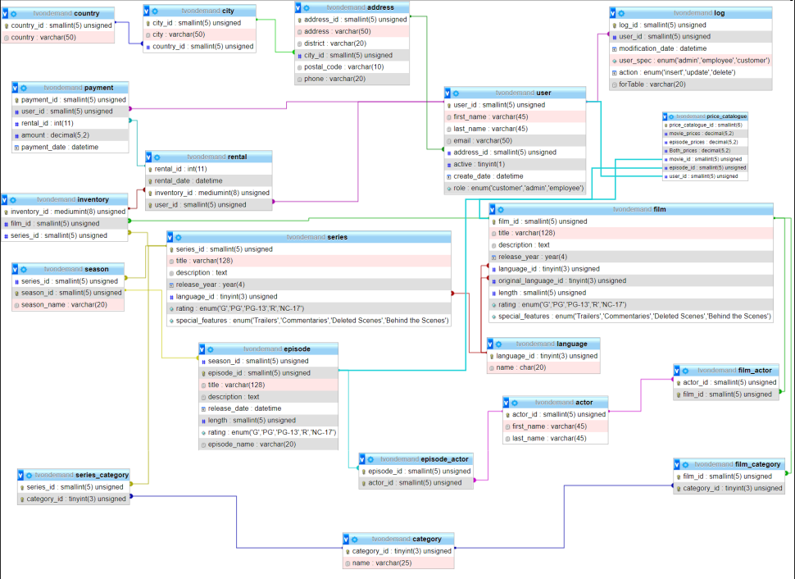

**Β)**

Στους πίνακες: actor, country, city, address, category, language, movie, movie_actor, movie_category, rental και payment δεν έγινε καμία τροποποίηση και βρίσκονται όλοι μαζί στον φάκελο Create-Insert στο αρχείο Starting_DB.

Οι πίνακες που χρειάστηκαν τροποποίηση είναι οι: customer και inventory.

Τον πίνακα customer τον αλλάξαμε σε πίνακα user και του προσθέσαμε το column ‘role’ με SET τους ρόλους που μπορεί να έχει ένας user όπως customer, admin και employee με το σκεπτικό ότι ένας administrator μπορεί να είναι και customer και ένας employee το ίδιο. Επίσης του προσθέσαμε ένα column ‘type_of_reg’ για τον τύπο εγγραφής, αν δηλαδή έκανε εγράφη για να βλέπει μόνο σειρές, μόνο ταινίες ή και τα δυο.

DROP TABLE IF EXISTS `user`; CREATE TABLE IF NOT EXISTS `user` ( `user_id` smallint(5) UNSIGNED NOT NULL AUTO_INCREMENT, `first_name` varchar(45) NOT NULL, `last_name` varchar(45) NOT NULL, `email` varchar(50) DEFAULT NULL, `address_id` smallint(5) UNSIGNED NOT NULL, `active` tinyint(1) NOT NULL DEFAULT '1', `create_date` datetime NOT NULL, `role` set('customer','admin','employee') DEFAULT 'customer', `type_of_reg` enum('series','movies','both') DEFAULT NULL, PRIMARY KEY (`user_id`), KEY `fk_customer_address` (`address_id`) );

Στον πίνακα inventory απλά προσθέσαμε το column series_id καθώς σε ένα inventory μπορεί να υπάρχουν ή ταινίες ή σειρές ή και τα δυο.

DROP TABLE IF EXISTS `inventory`; CREATE TABLE IF NOT EXISTS `inventory` ( `inventory_id` mediumint(8) UNSIGNED NOT NULL AUTO_INCREMENT, `movie_id` smallint(5) UNSIGNED DEFAULT NULL, `series_id` smallint(5) UNSIGNED DEFAULT NULL, PRIMARY KEY (`inventory_id`), KEY `fk_inventory_movie` (`movie_id`), KEY `fk_inventory_series` (`series_id`) );

Αυτοί οι δυο τροποποιημένοι πίνακες δίνονται μαζί με τους νέους πίνακες.

**ΚΕΦΑΛΑΙΟ 2**

Σε αυτό το κεφάλαιο δίνεται η περιγραφή των νέων πινάκων που χρειάστηκε να φτιάξουμε για την υλοποίηση του Project.

-- Δημιουργία πίνακα 'series'

DROP TABLE IF EXISTS `series`; CREATE TABLE IF NOT EXISTS `series` ( `series_id` smallint(5) UNSIGNED NOT NULL AUTO_INCREMENT, `title` varchar(128) NOT NULL, `description` text, `release_year` year(4) DEFAULT NULL, `language_id` tinyint(3) UNSIGNED NOT NULL, `rating` enum('G','PG','PG-13','R','NC-17') DEFAULT 'G', `special_features` enum('Trailers','Commentaries','Deleted Scenes','Behind the Scenes') DEFAULT NULL, `original_language_id` tinyint(3) UNSIGNED DEFAULT NULL, PRIMARY KEY (`series_id`), KEY `fk_series_language` (`language_id`) );

* Παρόμοιος με τον πίνακα movie χωρίς το column ‘length’ καθώς αυτό το προσθέσαμε στον πίνακα ‘episode’.

-- Δημιουργία πίνακα 'season'

DROP TABLE IF EXISTS `season`; CREATE TABLE IF NOT EXISTS `season` ( `series_id` smallint(5) UNSIGNED DEFAULT NULL, `season_id` smallint(5) UNSIGNED NOT NULL, `season_name` varchar(20) NOT NULL, PRIMARY KEY (`season_id`), KEY `fk_season_series` (`series_id`) );

* Πίνακας ‘season’ που δείχνει τους κύκλους μιας σειράς

--Δημιουργία πίνακα 'episode'

DROP TABLE IF EXISTS `episode`; CREATE TABLE IF NOT EXISTS `episode` ( `episode_id` int(11) NOT NULL AUTO_INCREMENT, `season_id` int(11) NOT NULL, `title` varchar(128) NOT NULL, `description` text, `release_date` datetime DEFAULT NULL, `length` varchar(255) DEFAULT NULL, `rating` enum('G','PG','PG-13','R','NC-17') DEFAULT 'G', PRIMARY KEY (`episode_id`), KEY `fk_episode_season` (`season_id`) );

* Πίνακας ‘episode’ που δείχνει τα επεισόδια που έχει κάθε κύκλος. Σε αυτό το table προσθέσαμε το length.

--Δημιουργία πίνακα 'episode_actor'

DROP TABLE IF EXISTS `episode_actor`; CREATE TABLE IF NOT EXISTS `episode_actor` ( `episode_id` smallint(5) UNSIGNED NOT NULL, `actor_id` smallint(5) UNSIGNED NOT NULL, PRIMARY KEY (`episode_id`,`actor_id`), KEY `fk_episode_actor_actor` (`actor_id`) );

* Πίνακας ‘episode _actor’ που δείχνει τους ηθοποιούς και τις τα επεισόδια στα οποία παίζουν.

-- Δημιουργία πίνακα 'series_category'

DROP TABLE IF EXISTS `series_category`; CREATE TABLE IF NOT EXISTS `series_category` ( `series_id` smallint(5) UNSIGNED NOT NULL, `category_id` tinyint(3) UNSIGNED NOT NULL AUTO_INCREMENT, PRIMARY KEY (`series_id`,`category_id`), KEY `fk_series_category_category` (`category_id`) );

* Πίνακας ‘series_category’ που δείχνει σε τι κατηγορία ανήκει κάθε σειρά

--Δημιουργία πίνακα 'log'

DROP TABLE IF EXISTS `log`; CREATE TABLE IF NOT EXISTS `log` ( `log_id` smallint(5) UNSIGNED NOT NULL AUTO_INCREMENT, `user_id` smallint(5) UNSIGNED NOT NULL, `modification_date` datetime NOT NULL, `user_spec` enum('admin','employee','customer')DEFAULT 'customer', `action` enum('insert','update','delete') NOT NULL, `forTable` varchar(20) DEFAULT NULL, PRIMARY KEY (`log_id`), KEY `fk_log_user` (`user_id`) );

* Πίνακας ‘log’ στον οποίο καταγράφονται οι ενέργειες που εκτελούνται από οποιονδήποτε χρήστη (user_id και user_spec) και σε ποιόν πίνακα εκτελούνται (forTable) καθώς και πότε ακριβώς έγινε η ενέργεια.

-- Δημιουργία πίνακα `price_list`

DROP TABLE IF EXISTS `price_list`; CREATE TABLE IF NOT EXISTS `price_list` ( `price_list_id` smallint(6) NOT NULL AUTO_INCREMENT, `movie_prices` decimal(5,2) DEFAULT NULL, `episode_prices` decimal(5,2) DEFAULT NULL, `Both_prices` decimal(5,2) DEFAULT NULL, `movie_id` smallint(5) UNSIGNED NOT NULL, `episode_id` smallint(5) UNSIGNED NOT NULL, `user_id` smallint(5) UNSIGNED NOT NULL, PRIMARY KEY (`price_list_id`), KEY `fk_price_list_movie` (`movie_id`), KEY `fk_price_list_user` (`user_id`), KEY `fk_price_list_series` (`episode_id`) );

* Πίνακας price_list ο οποίος αποτελεί το μενού και στον οποίο καταγράφεται το ποσό της ταινίας (0,4), το ποσό του επεισοδίου (0,3) αλλά και το ποσό και των δυο μαζί (0,4 αφού είναι 0,3 ανά ταινία και 0,1 ανά επεισόδιο).

**ΚΕΦΑΛΑΙΟ 3**

Σε αυτό το κεφάλαιο δίνονται οι Stored Procedures

-- 3.1 procedure

-- CALL Procedure1('m', 4, '2002-10-05', '2011-05-09');

-- CALL Procedure1('s', 2, '2002-10-05', '2011-05-09');

DROP PROCEDURE IF EXISTS Procedure1;

DELIMITER $$

CREATE PROCEDURE Procedure1

( IN charactiras char(1), IN arithmos INT, IN begin_date DATE, IN end_date DATE )

BEGIN

IF (charactiras LIKE 'm')

THEN

SELECT COUNT(*) AS Number,

movie.movie_id AS KwdikosEidous,

movie.title AS PliresTitlos

FROM rental

INNER JOIN inventory ON rental.inventory_id = inventory.inventory_id

ΙNNER JOIN movie ON inventory.movie_id = movie.movie_id

WHERE rental.rental_date BETWEEN begin_date AND end_date

GROUP BY movie.title

ORDER BY Number DESC

LIMIT 0, arithmos;

ELSE SELECT COUNT(*) AS Number, series.series_id AS KwdikosEidous, series.title AS PliresTitlos

FROM rental

INNER JOIN inventory ON rental.inventory_id = inventory.inventory_id

INNER JOIN series ON inventory.series_id = series.series_id

WHERE rental.rental_date BETWEEN begin_date AND end_date

GROUP BY series.title

ORDER BY Number DESC

LIMIT 0, arithmos;

END IF;

END$$

DELIMITER ;

--

-- 3.2 procedure

--

-- call Procedure2('s','APRIL.BURNS@sakilacustomer.org', '2005-06-20');

DROP PROCEDURE IF EXISTS Procedure2;

DELIMITER $$

CREATE PROCEDURE Procedure2

(

IN email VARCHAR(50),

IN Hmerominia DATE

)

BEGIN

SELECT COUNT (rental_id) AS Rentals

FROM rental

INNER JOIN user ON rental.user_id = user.user_id

WHERE user.email = email

and DATE(rental.rental_date) LIKE Hmerominia;

END$$

DELIMITER ;

--

-- 3.3 procedure

--

DROP PROCEDURE IF EXISTS Procedure3;

delimiter $$

create procedure Procedure3()

begin

-- counter = metraei tous mhnes apo ton 1o ews ton 12o

declare counter int;

declare movie_count_both int;

declare movie_count_movies int;

declare episodes_count_both int;

declare episodes_count_series int;

declare earnings float;

set counter = 0;

while counter <= 12 do

-- movie_count_both = to noumero twn atomwn pou exoun enikiasei tainies, kai plhrwnoun 0.3 € ana tainia

set movie_count_both = (

SELECT count(movie.movie_id) as number_of_movies FROM movie

INNER JOIN inventory ON movie.movie_id=inventory.movie_id

INNER JOIN rental ON inventory.inventory_id=rental.inventory_id

WHERE month(rental.rental_date) LIKE counter

and rental.user_id IN (SELECT user_id from user where type_of_reg = 'both')

);

-- movie_count_movies = to noumero twn atomwn pou exoun enikiasei tainies, kai plhrwnoun 0.4 € ana tainia

set movie_count_movies = (

SELECT count(movie.movie_id) as number_of_movies FROM movie

INNER JOIN inventory ON movie.movie_id=inventory.movie_id

INNER JOIN rental ON inventory.inventory_id=rental.inventory_id

WHERE month(rental.rental_date) LIKE counter

and rental.user_id IN (SELECT user_id from user where type_of_reg = 'movies')

);

-- series_count_both = to noumero twn atomwn pou exoun enikiasei seires, kai plhrwnoun 0.1 € ana epeisodio seiras

set episodes_count_both = (

SELECT count(`episode_id`) from `episode`

inner join `season` on `episode`.`season_id` = `season`.`season_id`

inner join `series` on `season`.`series_id` = `series`.`series_id`

WHERE series.series_id IN (

SELECT series.series_id AS number_of_series FROM series

INNER JOIN inventory ON series.series_id = inventory.series_id

INNER JOIN rental ON inventory.inventory_id = rental.inventory_id

WHERE month(rental.rental_date) LIKE 5

and rental.user_id IN (SELECT user_id from user where type_of_reg = 'both'))

);

-- series_count_series = to noumero twn atomwn pou exoun enikiasei seires, kai plhrwnoun 0.2 € ana epeisodio seiras

set episodes_count_series = (

SELECT count(`episode_id`) from `episode`

inner join `season` on `episode`.`season_id` = `season`.`season_id`

inner join `series` on `season`.`series_id` = `series`.`series_id`

WHERE series.series_id IN (

SELECT series.series_id AS number_of_series FROM series

INNER JOIN inventory ON series.series_id = inventory.series_id

INNER JOIN rental ON inventory.inventory_id = rental.inventory_id

WHERE month(rental.rental_date) LIKE 5

and rental.user_id IN (SELECT user_id from user where type_of_reg = 'series'))

);

set earnings = movie_count_both * 0.3 + movie_count_movies * 0.4 + episodes_count_both * 0.1 + episodes_count_series * 0.2;

-- emfanizw ta apotelesmata se mhnes

IF (counter = 0) THEN

select earnings as January_Earnings;

ELSE IF (counter = 1) THEN

select earnings as February_Earnings;

ELSE IF (counter = 2) THEN

select earnings as March_Earnings;

ELSE IF (counter = 3) THEN

select earnings as April_Earnings;

ELSE IF (counter = 4) THEN

select earnings as May_Earnings;

ELSE IF (counter = 5) THEN

select earnings as June_Earnings;

ELSE IF (counter = 6) THE

select earnings as July_Earnings;

ELSE IF (counter = 7) THEN

select earnings as August_Earnings;

ELSE IF (counter = 8) THEN

select earnings as September_Earnings;

ELSE IF (counter = 9) THEN

select earnings as October_Earnings;

ELSE IF (counter = 10) THEN

select earnings as November_Earnings;

ELSE IF (counter = 11) THEN

select earnings as December_Earnings;

END IF;

set counter = counter +1;

end while;

end$$

-- 3.4.a procedure

--

DROP PROCEDURE IF EXISTS Procedure4;

DELIMITER $$

CREATE PROCEDURE Procedure4

(

IN first_last_name VARCHAR(45),

IN end_last_name VARCHAR(45)

)

BEGIN

SELECT count(`actor_id`) as plhthos FROM actor

WHERE last_name between first_last_name and end_last_name;

SELECT `first_name`, `last_name` FROM actor

WHERE last_name between concat(first_last_name, '%') and concat( end_last_name, '%')

ORDER BY last_name ASC;

END$$

DELIMITER ;

--call Procedure4('Aco', 'Alm');

-- for 3.4.b

-- make an index first

--

ALTER TABLE `actor` ADD INDEX actor_index_last_name(last_name);

--

-- 3.4.b procedure

--

DROP PROCEDURE IF EXISTS Procedure5;

DELIMITER $$

CREATE PROCEDURE Procedure5

(

IN last_name VARCHAR(45)

)

BEGIN

declare count_actors int;

-- check if there are more than 1 results

set count_actors = (select count(*) from actor where actor.last_name = last_name);

IF (count_actors > 1) THEN

select count_actors as plhthos;

END IF;

select `actor_id`, `first_name`, `last_name` from actor

where actor.last_name = last_name;

END$$

DELIMITER ;

-- 1 result

-- call Procedure4('GUINESS');

-- more than 1 results

-- call Procedure4('Livingston');

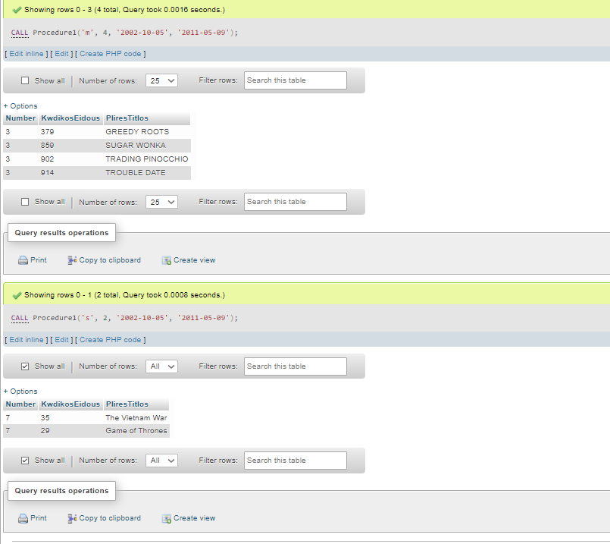

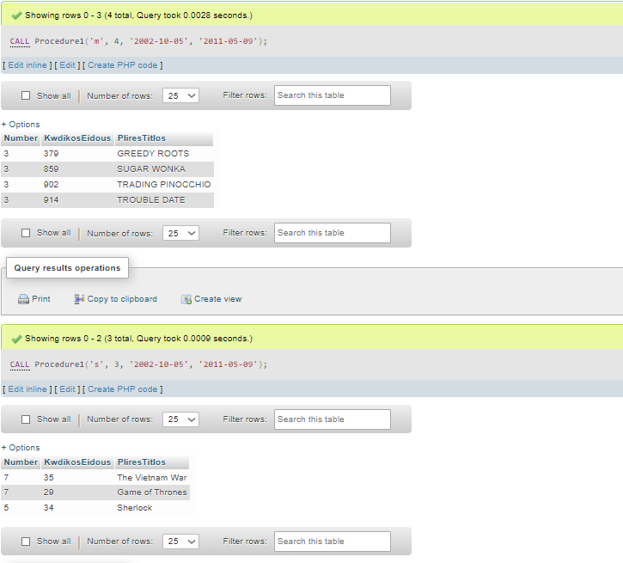

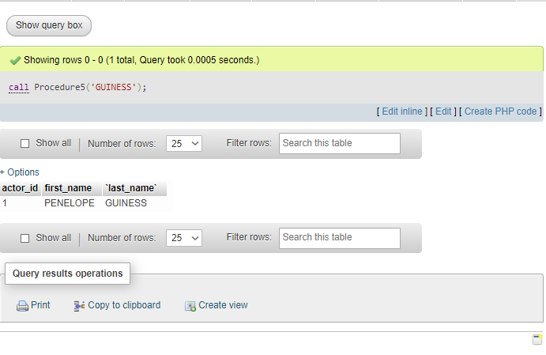

* Οι Stored Procedures δίνονται και στον φάκελο StoredProcedures σε .SQL αρχείο.

**ΚΕΦΑΛΑΙΟ 4**

Σε αυτό το κεφάλαιο δίνονται τα Triggers.

-- trigger1

-- user

--

delimiter //

CREATE TRIGGER enimerwsi_log_1_1

BEFORE INSERT ON user

FOR EACH ROW

BEGIN

INSERT INTO log(user_spec, action, forTable) VALUES('customer', 'insert', 'user');

END//

--

CREATE TRIGGER enimerwsi_log_1_2

BEFORE UPDATE ON user

FOR EACH ROW

BEGIN

INSERT INTO log(user_spec, action, forTable) VALUES('customer','update', 'user');

END//

--

CREATE TRIGGER enimerwsi_log_1_3

BEFORE DELETE ON user

FOR EACH ROW

BEGIN

INSERT INTO log(user_spec, action, forTable) VALUES('customer','delete', 'user');

END//

--

-- rental

--

CREATE TRIGGER enimerwsi_log_1_4

BEFORE INSERT ON rental

FOR EACH ROW

BEGIN

INSERT INTO log(user_spec, action, forTable) VALUES('customer', 'insert', 'rental');

END//

--

CREATE TRIGGER enimerwsi_log_1_5

BEFORE UPDATE ON rental

FOR EACH ROW

BEGIN

INSERT INTO log(user_spec, action, forTable) VALUES('customer','update', 'rental') ;

END//

--

CREATE TRIGGER enimerwsi_log_1_6

BEFORE DELETE ON rental

FOR EACH ROW

BEGIN

INSERT INTO log(user_spec, action, forTable) VALUES('customer','delete', 'rental');

END//

--

-- inventory

--

CREATE TRIGGER enimerwsi_log_1_7

BEFORE INSERT ON inventory

FOR EACH ROW

BEGIN

INSERT INTO log(user_spec, action, forTable) VALUES('customer', 'insert', 'inventory');

END//

--

CREATE TRIGGER enimerwsi_log_1_8

BEFORE UPDATE ON inventory

FOR EACH ROW

BEGIN

INSERT INTO log(user_spec, action, forTable) VALUES('customer','update', 'inventory') ;

END//

--

CREATE TRIGGER enimerwsi_log_1_9

BEFORE DELETE ON inventory

FOR EACH ROW

BEGIN

INSERT INTO log(user_spec, action, forTable) VALUES('customer','delete', 'inventory');

END//

--

-- payment

--

CREATE TRIGGER enimerwsi_log_1_10

BEFORE INSERT ON payment

FOR EACH ROW

BEGIN

INSERT INTO log(user_spec, action, forTable) VALUES('customer', 'insert', 'payment');

END//

--

CREATE TRIGGER enimerwsi_log_1_11

BEFORE UPDATE ON payment

FOR EACH ROW

BEGIN

INSERT INTO log(user_spec, action, forTable) VALUES('customer','update', 'payment') ;

END//

--

CREATE TRIGGER enimerwsi_log_1_12

BEFORE DELETE ON payment

FOR EACH ROW

BEGIN

INSERT INTO log(user_spec, action, forTable) VALUES('customer','delete', 'payment');

END//

delimiter ;

--

-- StoredProcedure gia to trigger2

--

DROP PROCEDURE IF EXISTS ProcedureEkptwsi;

DELIMITER $$

CREATE PROCEDURE ProcedureEkptwsi

(

IN Username VARCHAR(25),

IN Hmerominia DATE

)

BEGIN

SELECT COUNT (rental_id) AS Enoikiaseis

FROM rental

INNER JOIN user ON rental.user_id=user.user_id

WHERE rental.rental_date=CURRENT_TIMESTAMP

GROUP BY user.email;

IF Enoikiaseis>=3 THEN

SELECT amount FROM rental INNER JOIN payment

ON rental.rental_id=payment.rental_id;

UPDATE payment.amount SET payment.amount=payment.default_price/2;

ELSE

SELECT updated_amount FROM rental INNER JOIN payment

ON rental.rental_id=payment.rental_id;

UPDATE payment.amount SET payment.amount=payment.default_price;

END IF;

END;

END$$

--

-- trigger2

--

DELIMITER #

CREATE TRIGGER EKPTWSH

BEFORE UPDATE ON rental FOR EACH ROW

BEGIN

CALL ProcedureEkptwsi;

END;

END#

DELIMITER ;

--

--trigger3

--

DROP PROCEDURE IF EXISTS DENIED_1;

DELIMITER $$DELIMITER $$

CREATE TRIGGER DENIED_user_updates

BEFORE UPDATE

ON user FOR EACH ROW

BEGIN

IF (old.`user_id` <> new.`user_id`) THEN

SIGNAL SQLSTATE '45000' SET MESSAGE_TEXT = 'User Id cannot change!!';

ELSEIF (old.`first_name` <> new.`first_name`) THEN

SIGNAL SQLSTATE '45000' SET MESSAGE_TEXT = 'A user first name cannot change!!';

ELSEIF (old.`last_name` <> new.`last_name`) THEN

SIGNAL SQLSTATE '45000' SET MESSAGE_TEXT = 'A user last name cannot change!!';

ELSEIF (old.`create_date` <> new.`create_date`) THEN

SIGNAL SQLSTATE '45000' SET MESSAGE_TEXT = 'A user created date cannot change!!';

END IF;

END$$

* Τα triggers δίνονται και στον φάκελο Triggers σε μορφή .SQL

**ΙΣΤΟΣΕΛΙΔΕΣ ΠΟΥ ΧΡΗΣΙΜΟΠΟΙΗΘΗΚΑΝ**

* <https://docs.microsoft.com/en-us/sql>
* [https://www.w3schools.com/sql](https://www.w3schools.com/sql/default.asp)
* <https://www.sqlservertutorial.net/sql>
* <https://docs.oracle.com/cd/E17952_01/index.html>